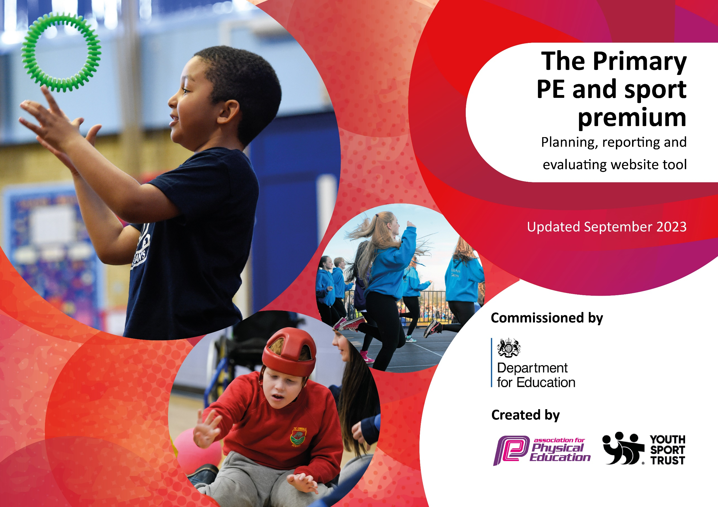

Updated July 2024

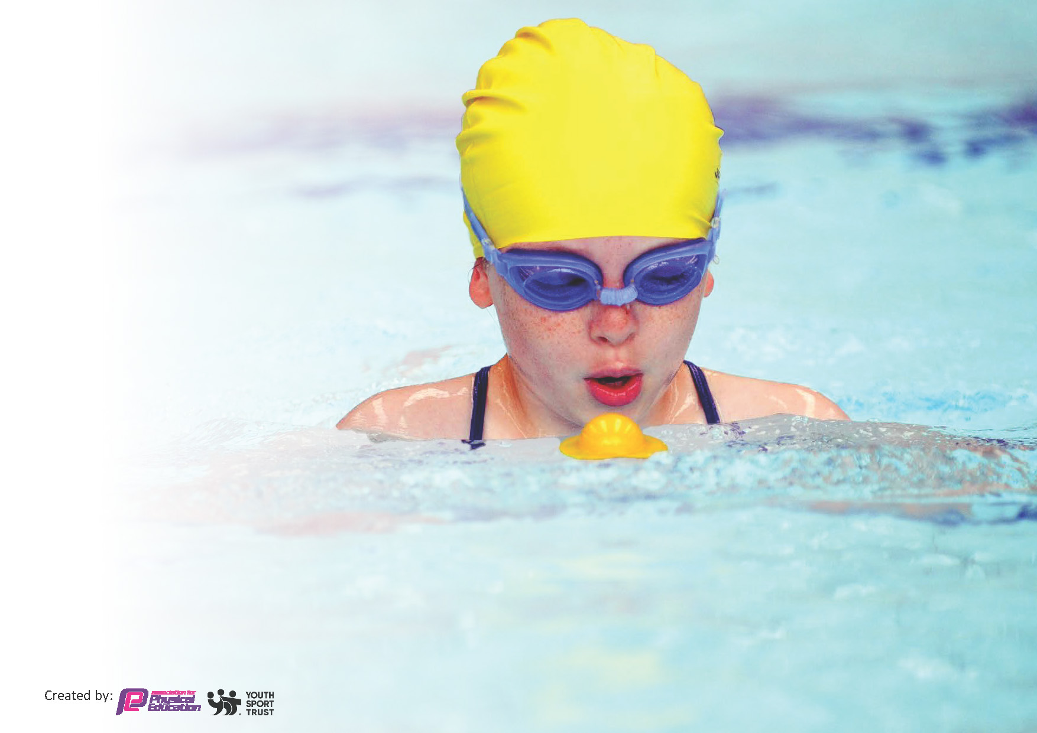
This template can be used for multiple purposes:
by:
- It enables schools to effectively plan their use of the Primary PE and sport premium
- It helps schools to meet the requirements (as set out in guidance) to publish information on their Primary PE and sport premium
- It will be an effective document to support Ofsted inspections enabling schools to evidence progress in Physical Education (PE) and evidence swimming attainment, which forms part of the PE National Curriculum. We would recommend schools consider
the Intent, Implementation and Impact of any spend, as examined within the Education Inspection Framework.

It is important that your grant is used effectively and based on school need.

Schools must use the funding to make additional and sustainable
improvements to the quality of the PE, School Sport and Physical Activity (PESSPA)
they offer. This means that you should use the Primary PE and sport premium to:

- Build capacity and capability within the school to ensure that improvements made now will benefit pupils joining the school in future years
- Develop or add to the PESSPA activities that your school already offers.

The Primary PE and sport premium should not be used to fund capital spend projects; the school’s core budget should fund these. Further detail on capital expenditure can be found in the updated Primary PE and sport premium guidance.

The Primary PE and sport premium guidance, outlines 5 key priorities that funding should be used towards. It is not
necessary that spending has to meet all the key priorities, you should select the priorities that you aim to use any funding towards.

Although completing this template is not a requirement for schools, schools are required to publish details of how they spend this funding. Schools must also outline what the impact this funding has had on pupils’ PE and sport participation and attainment and how any spending will be sustainable in the future. All funding must be spent by 31st July 2024.

The Department for Education has worked closely with the Association for Physical Education (afPE) and the Youth Sport Trust (YST) to develop this template and encourages schools to use it. This template is an effective way of meeting the reporting requirements of the Primary PE and sport premium.

Key priorities and Planning
This planning template will allow schools to accurately plan their spending.

Action – what are you planning to do | Who does this action impact? | Key indicator to meet | Impacts and how sustainability will be achieved? | Cost linked to the action
To ensure that high quality physical activities are offered in school both within and beyond a rich PE curriculum  To ensure children understand how to lead a healthy life and make positive lifestyle choices through the delivery of an effective and beyond statutory PSHE/RHE & PE curriculum.  Increase the confidence, knowledge & skills of all staff in teaching PE & sport through effective CPD  Broaden pupils’ experiences across a range of sports and activities during and beyond the school day  Through a full curriculum and secure subject leadership, pupils will feel inspired to participate in competitions and will have the skills, knowledge and courage to do so confidently | Teaching staff, Play Leaders, Sports Coaches - as they need to lead the activities and lessons  Pupils – as they will take part.  Subject Leaders and Teaching staff delivering learning opportunities  Pupils – as they will take part.  Teaching staff, Play Leaders, Sports Coaches - as they need to lead the activities and lessons  Pupils – as they will take part.  Teaching staff, Play Leaders, Sports Coaches - as they need to lead the activities and lessons  Pupils – as they will take part.  Pupils – as they will take part. | Key indicator 1: The engagement of all pupils in regular physical activity – Chief Medical Officers guidelines recommend that primary school pupils undertake at least 30 minutes of physical activity a day in school  Key indicator 2: The profile of PESSPA being raised across the school as a tool for whole school improvement  Key indicator 3: Increased confidence, knowledge and skills of all staff in teaching PE and sport  Key indicator 4: Broader experience of a range of sports and activities offered to all pupils  Key indicator 5: Increased participation in competitive sport | Increased participation in the Daily Mile  Increased active and adventurous play through implementation of the OPAL scheme (AM)  Increased participation in daily before-school sport clubs (linked to pre-teaching PE curriculum skills for the term ahead) (SK)  Increased participation in after school sport clubs (linked to reinforcing and consolidating PE curriculum skills for the current term) (SK)  Active sessions during lunch breaks with a qualified Sports Coach (SK)  Purchase of the SSP package to support local cluster competition/activities  Effective subject leadership and mapping across PE & PSHE/RHE through development of the Pathway Curriculum (TW/SR)  Leadership/subject specific CPD for PE lead to support continuing professional development to develop subject leader knowledge and skills (TW)  Introduced specialist practitioners to work alongside teachers and upskill pedagogy  Developed and improved pathways to local/cluster hubs  Developed participation opportunities in activities beyond the curriculum e.g. Tri-Golf, Yoga, Orienteering, Forest Schools (TB)  Developed and resourced the before and after school provision  Maintained and replenished current sports equipment/facilities  Ensured access to inter-school sporting competitions & opportunities (LR)  PE leader created and delivered a timetable of competitive sporting events throughout the year.  Subsidised transport costs to ensure all pupils are able to participate | £8625  £914  £457  £7724  £inc. in above strategies

Key achievements 2023-2024
This template will be completed at the end of the academic year and will showcase the key achievements schools have made with their Primary PE and sport premium spending.

Activity/Action | Impact | Comments
Subject specific (Forest School) SK Level 3 Forest School. SK has now undertaken the Forest School course in addition to AB, TB and GB who are qualified.  Afterschool sports club (Variety of Team Games) – This is weekly.  New Sports Equipment relevant to the School Curriculum.  OPAL – Keyingham Primary have now achieved the Gold Standard Quality Mark for OPAL.  Red Caps  SSP Package  Brownlee Triathlon | All children have access to a Level 3 Practitioner. (AB, GB, TB, SK)  Children partake in Forest School Lessons lead by qualified staff. (Whole school participation).  Afterschool club – Weekly Forest School.  Lead by a qualified PE Coach. Accessing a variety of games/sports not necessarily linked to the national curriculum.  Children throughout the school have access to sports equipment which ensures that all children can partake in PE lessons. PE is now twice a week totaling 45 mins per lesson (1hr 30mins a week). At least one lesson a week is lead by a qualified PE Coach. (Active 60)  OPAL has played an integral part in PE, children have access to daily sport on the MUGA, games, roleplay and an assortment of equipment during lunch and playtime.  Children lead an activity as directed by OPAL Leader. This varies each playtime and lunchtime.  Cluster competitions children chose to take part in these activities.  22 children took part in the Brownlee Triathlon at Hymers College, an experience opened to all KS2 children who can swim unaided. | Children have access to Forest School teaching them resilience, curiosity and adaptability.  Continues classroom learning.  Children gain experience of a variety of games.  The ability to teach the curriculum to its full potential without the barrier of missing equipment.  Children learn to play together, teamwork, opportunities for children to experience new activities. Develop problem solving skills.  Children learn the role of leading an activity – essentially developing sports leaders.  Children took part in Swimming, Football, Rugby, Boccia, Dodgeball, Girls Football, Year 5 Intra Sports.  Experience a competitive event without the pressure of winning

Swimming Data
Meeting National Curriculum requirements for swimming and water safety.
Priority should always be given to ensuring that pupils can perform safe self-rescue even if they do not fully meet the first two requirements of the National Curriculum programme of study

Question | Stats: | Further context  Relative to local challenges
What percentage of your current Year 6 cohort can swim competently, confidently and proficiently over a distance of at least 25 metres? | 43% | We struggle to get pool space due to only having 10 swimming lessons allocated to the school per year. (Withernsea)
What percentage of your current Year 6 cohort can use a range of strokes effectively [for example, front crawl, backstroke, and breaststroke]? | 43% | Initially this figure is probably nearer 65% children are able to use a range of strokes, they are taught front crawl, backstroke and breaststroke but are unable to meet the national requirement of completing one full length (25m) unaided.

What percentage of your current Year 6 cohort are able to perform safe self-rescue in different water-based situations? | 65%
If your schools swimming data is below national expectation, you can choose to use the Primary PE and sport premium to provide additional top-up sessions for those pupils that did not meet National Curriculum requirements after the completion of core lessons. Have you done this? | No
Have you provided CPD to improve the knowledge and confidence of staff to be able to teach swimming and water safety? | No

Signed off by:

Head Teacher: | Victoria White
Subject Leader or the individual responsible for the Primary PE and sport premium: | Tammy Whiting (PE Lead)
Governor: | John Frankland (Chair of Governors)
Date: | 17.07.2024

